

V 1.2
June 2026
Xstep Design Specification
SMPL Header: Order Details

1 Purpose 3
2 Overview 3
3 Reasons for developing 4
4 Authorization 4
5 Assumptions/ Dependencies 4
6 XStep Layout Design 5
7 Function Module(s) 5
8 Pseudocode 5
9 Configuration Specification 6
10 Test Scenarios 6
11 Revision History 8

Purpose
This document outlines the design, along with the configuration specifications for the XStep “SMPL Header: Order Details”.

Overview
The SMPL Header: Order Details XStep displays an overview of high-level process order information.
The step provides functionality to jump to transaction COR3 for users to display the process order using a function button labeled as “Display Process Order”. Additionally, the following output fields are system-generated and populate automatically upon document initialization, providing operators with real-time order context for their manufacturing activities:
- Process Order Number
- Order Material
- Material Description
- Order Batch
- Order Quantity
The XStep contains two main input parameters:
- IV_HEADER - This can be changed in SiMPL MBR to display specific header text for the XStep
- IV_INSTR - This can be changed in SiMPL MBR to display a specific set of instructions for the XStep that will be displayed below the header
The XStep contains a button labeled as “Display Process Order”. The button is linked to the function module COPF_CALL_TRANSACTION and enables functionality for a user to jump to transaction COR3 to view the process order it was executed in. The user can navigate back to the EBR once finished in COR3.
The following output fields are automatically populated using standard SAP Valuation Symbols:
- “Process Order Number” - Output
- “Order Material” - Output
- “Material Description” - Output
- “Order Batch” - Output
- “Order Quantity” - Output
There is also an option to display a generated barcode that can be linked to a shop floor barcode for the order if required.

Functional Design
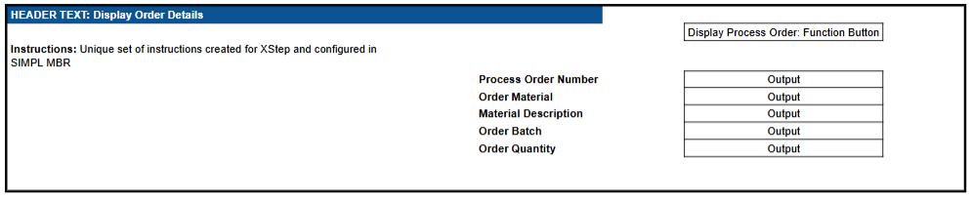

Reasons for developing
The primary goal of developing the SMPL Header: Order Details XStep is to display an overview of high-level process order information in order for the operator to verify that the correct batch record is being executed and to be able to jump to the specific Process Order to view additional details if needed.

Authorization
N/A

Assumptions/ Dependencies
 | Assumption
1 | The system has been configured to allow the usage of Standard SAP Valuation Symbols.
2 | The data stored in the system is up to date and correct.
3 | Warning messages are displayed if the data fails the validation check.

XStep Layout Design
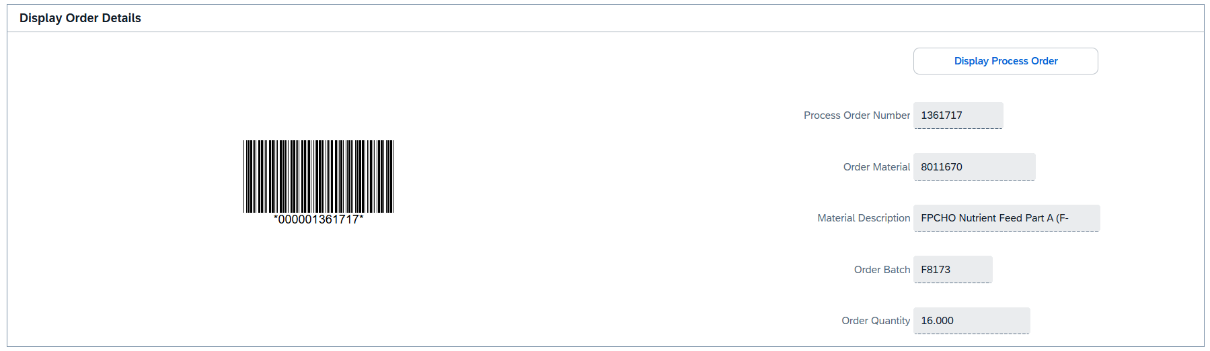

Function Module(s)
Function: COPF_CALL_TRANSACTION
Import Parameters:
Parameter Name | Associated Type | Short Text
TCODE | TCODE | Transaction Code
NEW_SESSION | FLAG | Start Transaction in New Session

Function: /SMPL/PPPI_FM_GI_SETUP_LINE
Import Parameters:
Parameter Name | Associated Type | Short Text
IV_WERKS | WERKS_D | Plant
IV_MAT | MATNR | Material
IV_DESC | MAKTX | Material description
IV_LGORT | LGORT_D | Storage location
IV_UOM | ERFME | UoM
IV_XCHPF | BOOLE_D | Boolean
IV_INDEX | CHAR30 | Index
IT_INDEX | /SMPL/STR_TT_SHORT_TEXT | Table of indexes
IV_ORDER | AUFNR | Order
IV_PHASE | VORNR | Phase
IV_QTY | ERFMG | Quantity
IV_DATE | DATS | Date
IV_TIME | TIMS | Time
IV_BATCH | CHARG_D | Batch

Export Parameters:
Parameter Name | Associated Type | Short Text
EV_WERKS | WERKS_D | Plant
EV_MAT | MATNR | Material
EV_MAT_D | MATNR | Material Default
EV_DESC | CHAR30 | Material description
EV_LGORT | LGORT_D | Storage location
EV_LGORT_D | LGORT_D | Storage location default
EV_UOM | ERFME | UoM
EV_UOM_D | ERFME | UoM Default
EV_ORDER | AUFNR | Order
EV_PHASE | VORNR | Phase
EV_QTY | ERFMG | Quantity
EV_QTY_D | ERFMG | Quantity Default
EV_DATE | DATS | Date
EV_TIME | TIMS | Time
EV_BAT | CHAR30 | Batch
EV_BAT_D | CHAR30 | Batch Default
EV_BAT_V | CHARG_D | Batch Variable

Pseudocode
Function: COPF_CALL_TRANSACTION
1. Check If Called via RFC
- Use standard function RFC_WITHIN_SAME_SYSTEM
- If true:
- Set flag l_rfc_flag = 'X'
- Always run transaction in the same session (override NEW_SESSION)
2. Handle Call in Same Session
Condition: NEW_SESSION is initial
a. Call the transaction using ABAP4_CALL_TRANSACTION
b. Check SY-SUBRC return code and handle:
- 1: Access denied → show message
- 2: Invalid TCode → show message
- 3: Other error → show message
c. If RFC call: display blank screen (CALL SCREEN 900)
3. Handle Call in a New Session
Condition: NEW_SESSION is set
a. Reinvoke this same function module asynchronously using STARTING NEW TASK
b. Monitor for:
- Communication failure → show error message
- System failure → show error message
c. If success → show message indicating new session started
4. Custom Enhancement Framework Handling
a. Use enhancement method /SMPL/EBR_CL_ENH_FWK=>GET_ENTRY
b. Lookup class/method from enhancement table using keys:
- 'SMPL_EBR' and 'CALL_JUMP_FUNCTION'
c. If class and method exist:
- Prepare parameter bindings:
  - IM_TCODE (import)
  - EX_RETURN (changing)
- Dynamically invoke method using CALL METHOD (class)=>(method)
- Handle all possible exceptions
- If EX_RETURN = 'X' → exit the function early
5. Additional Notes
- Supports dynamic extension through enhancement framework to allow runtime changes in logic.
- Built-in support for launching transactions from MES interfaces.
- Prevents infinite loops by explicitly controlling NEW_SESSION behavior when reinvoking the function.
- Includes graceful error handling and user feedback messaging.
- The WebSocket path appears tailored for custom UI5 EBR interfaces but is currently commented out.

Function: /SMPL/PPPI_FM_GI_SETUP_LINE

1. Direct Field Mapping
The code begins by directly passing the values of the input parameters to their corresponding output parameters. Several of these inputs are mapped to two different output fields (likely one for background processing and one for display purposes, indicated by the _d suffix).
- Material: iv_mat is assigned to ev_mat and ev_mat_d.
- Description: iv_desc is assigned to ev_desc.
- Storage Location: iv_lgort is assigned to ev_lgort and ev_lgort_d.
- Unit of Measure: iv_uom is assigned to ev_uom and ev_uom_d.
2. Batch Logic Check
Next, it checks if a batch number was provided in the input.
- IF iv_batch IS NOT INITIAL: This translates to "If the input batch field is not empty."
- If a batch was provided, it assigns that value to both ev_bat and ev_bat_v.
- ELSE: If the input batch field is empty, it explicitly sets ev_bat and ev_bat_v to blank strings ('').
3. Additional Field Mapping (20251029 Addition)
This section (marked by a developer comment indicating it was added in late 2025) performs more direct 1-to-1 mapping for manufacturing or purchasing data.
- Order: iv_order is assigned to ev_order.
- Phase: iv_phase is assigned to ev_phase.
- Quantity: iv_qty is assigned to ev_qty and ev_qty_d.
4. Date and Time Defaults
The code then ensures that the output always has a valid date and time, defaulting to the current system date/time if the user or program didn't explicitly provide one.
- Date: It checks if iv_date is empty (IS INITIAL). If it is empty, it assigns the current system date (sy-datum) to ev_date. If a date was provided, it passes that date through.
- Time: It checks if iv_time is empty. If it is empty, it assigns the local system time (sy-timlo) to ev_time. Otherwise, it passes the provided time through.
5. Batch Management Indicator Logic
Finally, the code determines what to display for the batch field based on whether the material is actually batch-managed.
- IF iv_xchpf NE abap_true AND iv_mat IS NOT INITIAL: This checks two conditions simultaneously:
  - Is the batch management flag (iv_xchpf) NOT true? (In standard SAP, XCHPF is the flag indicating a material requires batches).
  - Is the material number (iv_mat) not empty?
- If both are true (meaning a valid material was entered, but it does not require batches), it sets the display batch field (ev_bat_d) to 'N/A' (Not Applicable).
- ELSE: If the material is batch managed (or if no material was entered at all), it clears out the ev_bat_d field entirely using the CLEAR statement.

Configuration Specification
N/A

Test Scenarios
# | Scenario | Expected Result | Actual Result | Pass/ Fail
1 | Create and Release a Process Order with the pre-configured SiMPL Master Recipe and the relevant Production Version | Process Order created and Released containing SMPL Header: Order Details | Process Order created and Released containing SMPL Header: Order Details
2 | Open the EBR, and navigate to SMPL Header: Order Details | The EBR for the selected Process Order and Control Recipe opens successfully without any errors and the SMPL Header: Order Details is visible in | The EBR for the selected Process Order and Control Recipe opens successfully without any errors and the SMPL Header: Order Details is visible
3 | Upon opening the XStep, the Process Order Number, Order Material, Material Description, Order Batch and Order Quantity fields are auto-populated. | Process Order Details are automatically populated in the Output fields | Process Order Details are automatically populated in the Output fields
4 | Verify that the value/text entered in parameter IV_HEADER and parameter IV_INSTR in SiMPL MBR appears correctly in the XStep header | Header and instruction text are displayed as authored in SiMPL MBR | Header and instruction text are displayed as authored in SiMPL MBR
5 | Select the “Display Process Order” button | The function module COPF_CALL_TRANSACTION is triggered to open transaction COR3 for the current process order. | The process order is correctly opened in COR3.
6 | Exit COR3 and return to the PI Sheet | Return to SiMPL EBR without system errors or data loss. | SiMPL EBR tab remains open.

Revision History
Version No. | Description | Author | Date
1.1 | Initial Document (Functional requirements and technical specification) | Frieda van der Merwe | 10-06-2025
1.2 | The following Technical Spec sections added to spec: Function Module(s), and Pseudocode. | James Church | 19-06-2026

